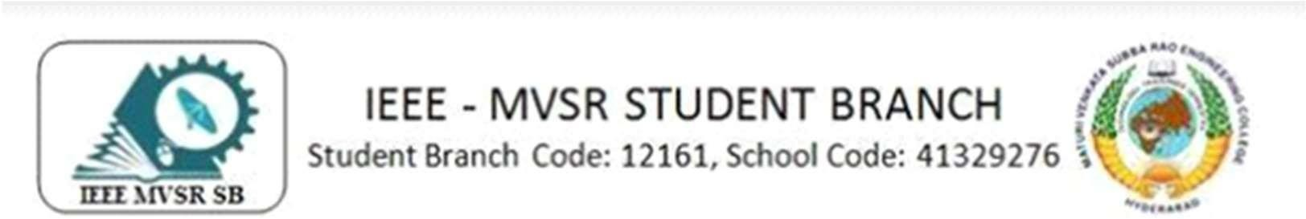

General Body Meeting WIE

IEEE MVSR SB Women in Engineering Student Chapter conducted the first General Body Meet of this year on 19th July,2023. The main intent of this meet was to plan and discuss the events to be conducted for this academic year.

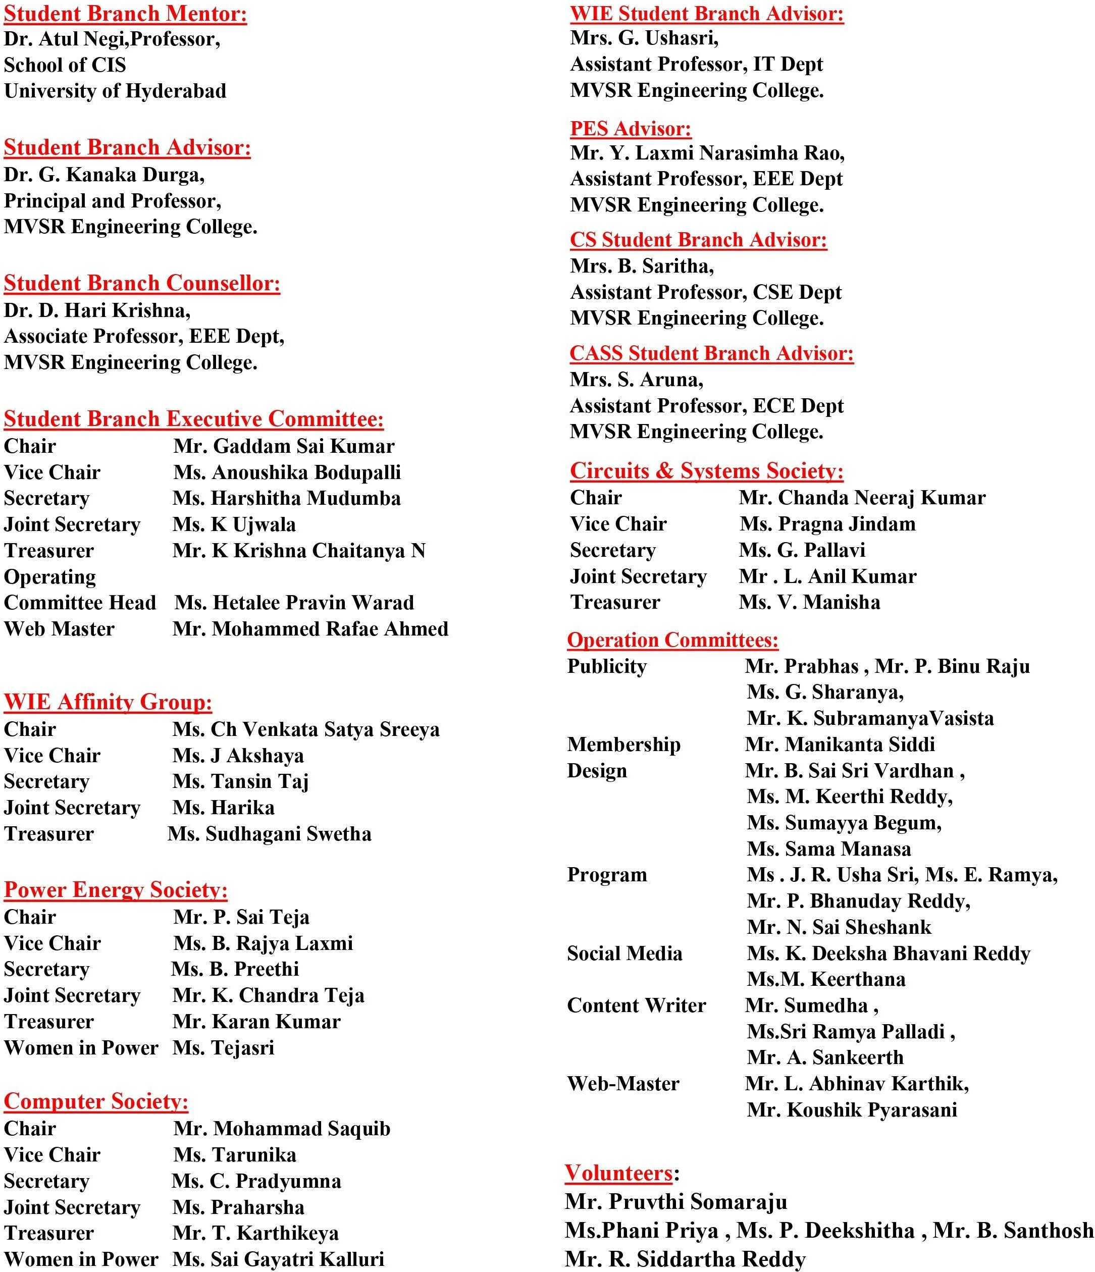

Session Details:
Date: 19th July, 2023

Time: 1:00pm - 2:30pm

Venue: IT-110 lab

Number of Attendees: 8

The meeting was commenced by Ms. Ch Venkata Satya Sreeya, Chairperson, IEEE MVSR SB WIE Student Chapter by congratulating the new WIE-ExCom and welcoming the gathering. Then Dr. D. Harikrishna, IEEE Student Branch Counsellor addressed the members and discussed several ideas mentioning the Membership drive, Cloth distribution. Later, the session was handed over to Mrs. G Ushasri, IEEE MVSR SB WIE Student Chapter Advisor addressed the gathering and discussed the purpose of the meet. Mr. G. Sai Kumar, Chairperson, IEEE MVSR SB suggested regarding the events to be held in the future. It has been discussed that a minimum of six events should be conducted, some of which have been discussed and planned during the meeting
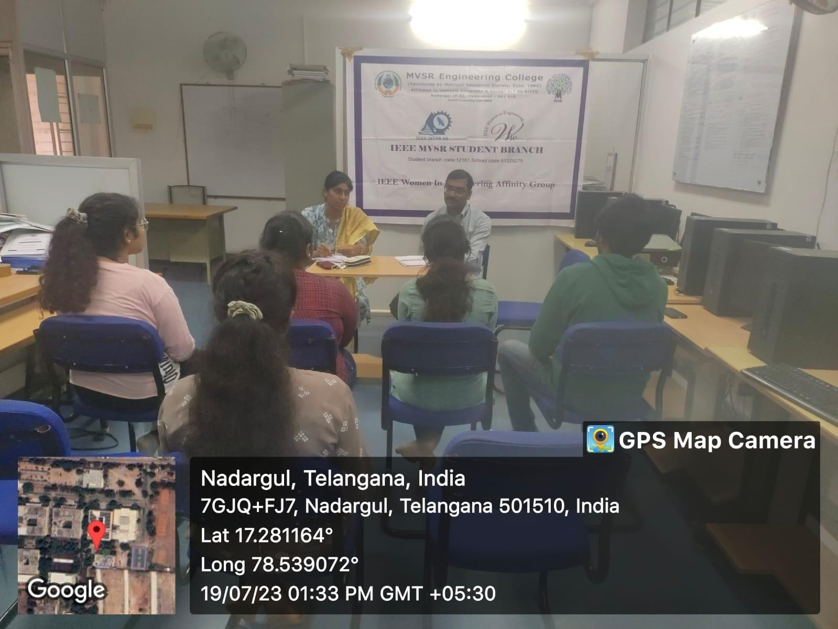
Dr. D. Harikrishna addressing the gathering

Firstly, Ms. Ch Venkata Satya Sreeya, Chairperson, IEEE MVSR WIE SB suggested organizing a Resume and LinkedIn Profile Building Session specifically for first-year students. This program will help students to get familiar with LinkedIn and other platforms to build their profiles. This event is planned to conduct before the membership drive. The second event discussed was a hands-on workshop on Neural Network using MATLAB is the second event. Students will learn about numerous areas and have some experience with

Neural Network as a result of this. A visit to an orphanage was also planned. The goal of this social cause is to increase women's understanding of menstruation hygiene.

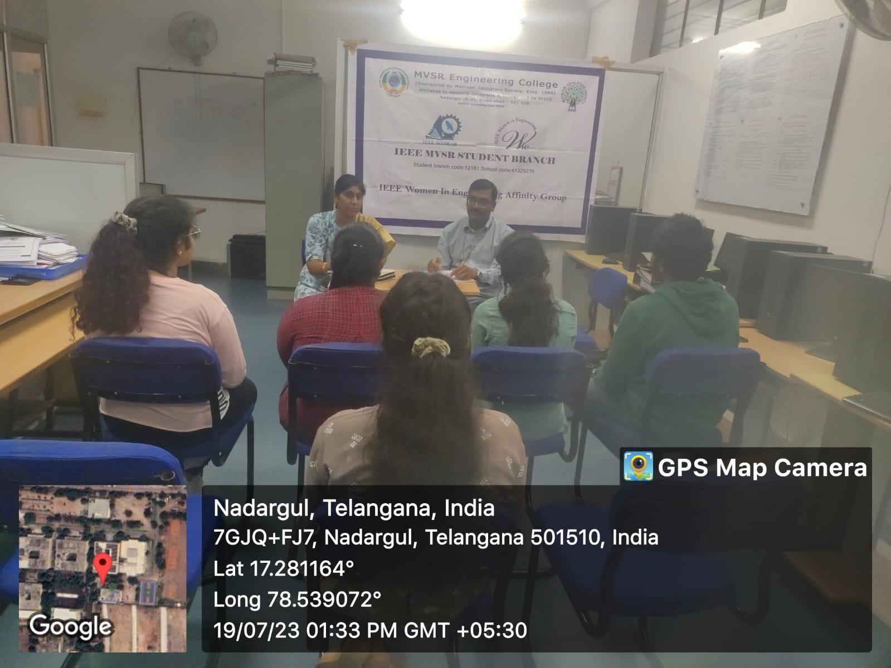
Upcoming events being discussed

Subsequently, Ms. Akshaya, Vice Chairperson, IEEE MVSR SB WIE suggested organizing a charity run in partnership with the NCC/NSS or Streetcause. This event aims to combine fitness, community engagement, making it a unique and purposeful endeavor. Later, Ms. Harika, Secretary, IEEE MVSR WIE, proposed a seminar on Business Analytics and Entrepreneurship. The IEEE MVSR SB WIE Student Chapter Advisor, Mrs. Ushasri, mentioned of organizing a women's day event. Even more she suggested to conduct a self-defense programme or a talk on mental health. Ms. Swetha, Treasurer, IEEE MVSR SB WIE suggested working with first years on the science fair event.

The meeting was concluded with a vote of gratitude by Ms. Tansin Taj, Secretary, IEEE MVSR SB WIE Student Chapter, in which Dr. D. Harikrishna, IEEE Student Branch Counsellor and Mrs. Ushasri, Advisor, IEEE MVSR SB WIE student chapter were acknowledged for their precious time. She thanked Mr. G. Sai Kumar, Chairperson, IEEE MVSR SB and all the members of IEEE MVSR SB WIE for attending the event.

List of Attendees:

S.No | Name of the participant | Roll No | IEEE ID
1 | Dr. D. Harikrishna | Faculty | 90436180
2 | Mrs. G. UshaSri | Faculty | 98612138
3 | G Sai Kumar | 2451-20-735-069 | 98196838
4 | Ch Venkata Satya Sreeya | 2451-20-737-151 | 97488096
5 | J.Akshaya | 2451-20-735-064 | 99216652
6 | Harika Rao | 2451-21-737-194 | 99229064
7 | Tansin Taj | 2451-21-733-059 | 99228530
8 | S.Swetha | 2451-20-734-060 | 99241090

Reported by:
IEEE MVSR SB

